Secure Online Voting System using Cryptography
(AES Algorithm)

Abstract
The Secure Online Voting System ensures the confidentiality and integrity of digital elections using Flask (Python) and AES encryption. Voters cast their votes through a web-based interface, where each vote is encrypted using AES before being stored in a SQLite database, preventing unauthorized access. Additionally, SHA-256 hashing is applied to voter IDs to maintain anonymity and prevent duplicate voting. The system decrypts votes securely for authorized result viewing, ensuring transparency. This approach enhances election security, minimizes fraud, and provides a scalable, lightweight solution for secure online voting.
Introduction
In the age of the internet, guarding the integrity and security of web-based voting is of utmost importance. This project demonstrates a secure online voting system developed using Python's Flask framework, SQLite as a database management system, and sophisticated cryptographic methods. The votes are encrypted using AES encryption before storage within the database, while voter identities are secured by SHA-256 hashing. These steps guarantee that even if the database is attacked, sensitive vote information is unavailable and safe.
By incorporating strong cryptographic techniques within a lightweight and accessible web platform, this system offers a secure platform for conducting online elections. The project not only shows how encryption and secure data processing can be applied in practice but also highlights the need for privacy and integrity within online voting systems. This method presents a scalable solution that can be added upon with more security features, providing an stepping stone towards full-featured secure online voting solutions.

Methodology
1.Install Required Packages:
1.1 Install Python (If Not Installed)
Flask runs on Python, so you need to install it first.
🔹 Check if Python is installed .Open Command Prompt (cmd) and run:
python –version
1.2Install Flask Using pip
Once Python is installed, run the following command in Command Prompt:
pip install flask
🔹 Check Flask Installation. After installation, verify Flask is installed by running:
python -m flask –version
1.3 Installing cryptography packages
To install the cryptography package for this project, run the following command
pip install cryptography
If you also need Flask and other dependencies, you can install them together:
pip install flask cryptography flask-cors
Navigate to the folder where you want to create your Flask app. For example, create a new directory:
Mkdir voting_system
cd voting_system
Running the Secure Voting System
Step 1: Start the Flask Server
Run the following command in the folder where app.py is located
python app.py
Step 2: Open in Browser
Voting Page: 👉 http://127.0.0.1:5000/zzz
Results Page: 👉 http://127.0.0.1:5000/results
Flowchart
This flowchart represents the execution of the project

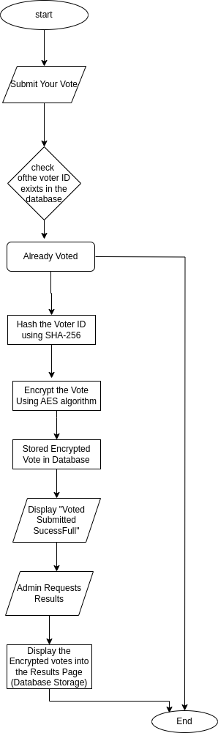
Code
Python app.py:
import sqlite3
import hashlib
from cryptography.fernet import Fernet
app = Flask(__name__)
# Generate AES encryption key
SECRET_KEY = Fernet.generate_key()
cipher = Fernet(SECRET_KEY)
# Database setup
def init_db():
conn = sqlite3.connect("votes.db")
cursor = conn.cursor()
cursor.execute('''
CREATE TABLE IF NOT EXISTS votes (
id INTEGER PRIMARY KEY AUTOINCREMENT,
voter_id TEXT UNIQUE,
encrypted_vote TEXT
)
''')
conn.commit()
conn.close()
# Hash function for voter ID
def hash_voter_id(voter_id):
return hashlib.sha256(voter_id.encode()).hexdigest()
@app.route("/", methods=["GET", "POST"])
def vote():
if request.method == "POST":
voter_id = hash_voter_id(request.form["voterId"]) # Hash voter ID
vote_choice = request.form["vote"]
# Encrypt vote
encrypted_vote = cipher.encrypt(vote_choice.encode()).decode()
try:
conn = sqlite3.connect("votes.db")
cursor = conn.cursor()
cursor.execute("INSERT INTO votes (voter_id, encrypted_vote) VALUES (?, ?)", (voter_id, encrypted_vote))
conn.commit()
conn.close()
return "Vote submitted successfully!"
except sqlite3.IntegrityError:
return "Error: This voter has already voted!"
return render_template("vote.html")
@app.route("/results")
def results():
conn = sqlite3.connect("votes.db")
cursor = conn.cursor()
cursor.execute("SELECT encrypted_vote FROM votes")
votes = cursor.fetchall()
conn.close()
return render_template("results.html", votes=[vote[0] for vote in votes])
if __name__ == "__main__":
init_db() # Initialize database
app.run(debug=True)
Frontend.html
<!DOCTYPE html>
<html>
<head>
<title>Secure Voting System</title>
</head>
<body>
<h2>Secure Online Voting</h2>
<form method="POST">
<label>Voter ID:</label>
<input type="text" name="voterId" required>
<br><br>
<label>Vote:</label>
<select name="vote">
<option value="Candidate A">Candidate A</option>
<option value="Candidate B">Candidate B</option>
</select>
<br><br>
<button type="submit">Submit Vote</button>
</form>
</body>
</html>

Results.html

<!DOCTYPE html>
<html>
<head>
<title>Voting Results</title>
</head>
<body>
<h2>Encrypted Votes</h2>
{% for vote in votes %}
<p>{{ vote }}</p>
{% endfor %}
</body>
</html>

Output

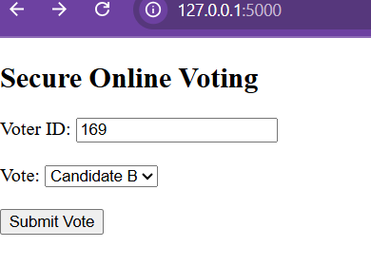

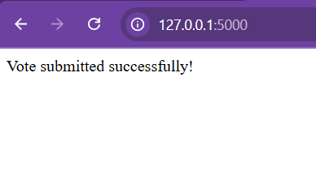

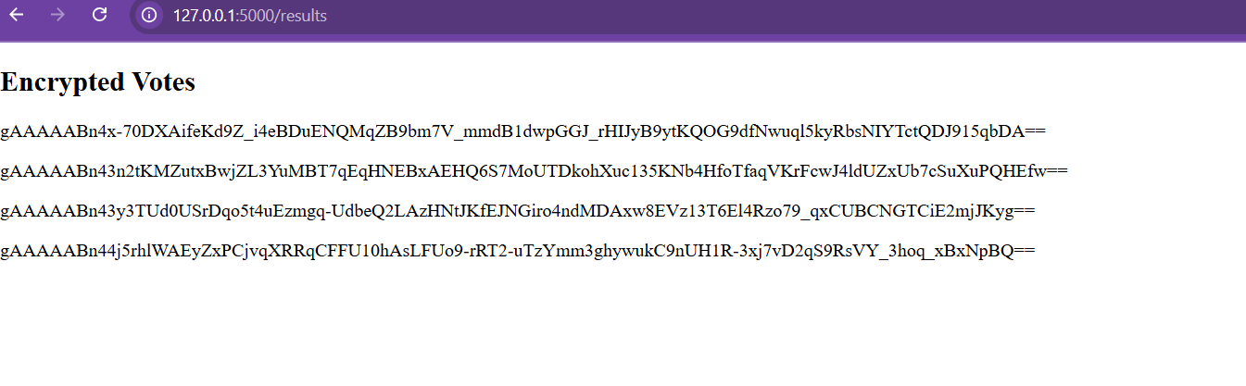
Conclusion
The Secure Online Voting System successfully enhances election security by encrypting votes and protecting voter identities. By using AES encryption for vote storage and SHA-256 hashing for identity verification, it ensures data integrity and prevents unauthorized access. The system provides a reliable, transparent, and tamper-proof voting process. Future improvements could include biometric authentication and blockchain technology to further strengthen security and trust in digital elections.

